NBKRIST
BASIC ELECTRICAL SCIENCES
LECTURE NOTES
UNIT-4
I.PRABHAKAR REDDY
DEPARTMENT OF ELECTRICAL AND ELECTRONICS ENGINEERING

NETWORK TOPOLOGY
When all the elements in a network are replaces by lines with circles or dots at both ends, configuration is called the graph of the network.
Graph: A graph is a collection of nodes joined by edges (line segments), the fig. 4.1 shows a small graph.
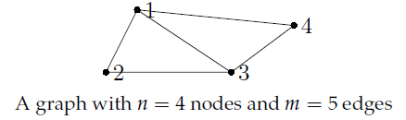
Fig. 4.1
Directed (or Oriented) graph:- A graph is said to be directed (or oriented ) when all the nodes and branches are numbered or direction assigned to the branches by arrow.
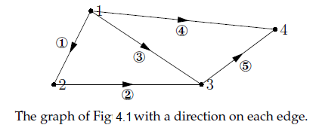
Fig. 4.2

Sub graph:- A graph G_{S} said to be sub-graph of a graph G if every node of G_{S} is a node of G and every branch of G_{S} is also a branch of G.
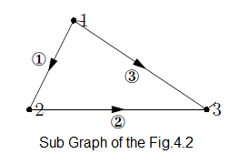
Fig. 4.3

Connected Graph:- When at least one path along branches between every pair of a graph exits , it is called a connected graph

- Terminology used in network graph:-
- Path:-A sequence of branches traversed in going from one node to another is called a path.
- Node:-A node point is defined as an end point of a line segment and exits at the junction between two branches or at the end of an isolated branch.
- Degree of a node: - It is the no. of branches incident to it. Example for Degree of node as shown in fig. 4.4
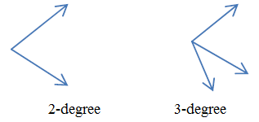
Fig. 4.4
- Tree: - It is a connected sub graph with no closed loops. It has only one path between any pair of nodes. A Graph has many trees. Some of the trees of graph shown in fig. 4.1.

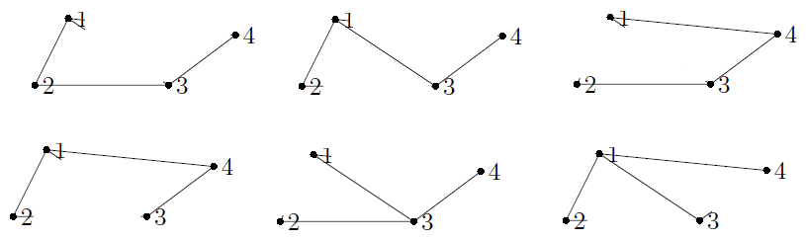
Fig. 4.5 some of the Trees of Graph shown in fig. 4.1

Properties of a Tree-
(i) It consists of all the nodes of the graph.
(ii) If the graph has N nodes, then the tree has (N-1) branch.
(iii) There will be no closed path in a tree.
(iv) There can be many possible different trees for a given graph depending on the no. of nodes and branches.

- Co-Tree: collection of branches that are not part of the tree.

- Tree branch (Twig):- It is the branch of a tree. It is also named as twig.

- Tree link (or chord):-It is the branch of a co-tree.

- Loop:- This is a closed path in a graph.

Relation between twigs and links-
Let N=no. of nodes
L= total no. of links
B= total no. of branches
No. of twigs= N-1
Then, L= B-(N-1)
Incidence matrix (Node-Incidence Matrix):- Any oriented graph can be described completely in a compact matrix form. Here we specify the orientation of each branch in the graph and the nodes at which this branch is incident. This matrix is called incident matrix. When one row is completely deleted from the matrix the remaining matrix is called a reduced incidence matrix.

FORMATION OF INCIDENCE MATRIX:-
• This matrix shows which branch is incident to which node.
• Each row of the matrix being representing the corresponding node of the graph.
• Each column corresponds to a branch.
• If a graph contain N- nodes and B branches then the size of the incidence matrix [A] will be NXB.

A. Procedure:-
(i) If the branch j is incident at the node I and oriented away from the node, a_{ij} =1. In other words, when a_{ij} =1, branch j leaves away node i.
(ii) If branch j is incident at node j and is oriented towards node i, a_{ij} =-1. In other words j enters node i.
(iii) If branch j is not incident at node i. a_{ij} =0.
The complete set of incidence matrix is called augmented incidence matrix.

Example:

Isomorphism:- It is the property between two graphs so that both have got same incidence matrix.

Cut-Set:- It is that set of elements or branches of a graph that separated two parts of a graph(network). If any branch of the cut-set is not removed, the network remains connected.

Example: cut-Sets: i) {f, b, d, c} ii) {f, a, c} iii) {c, d, e} and
iv) {a, b, d}

Basic cutest: it is a cut set containing only one tree branch.
Example:

Basic cutset matrix (Q-matrix):
- The Q-matrix describes the way the basic cutset is chosen.
- Each column corresponds to a branch (b columns).
- Each row corresponds to a basic cutset (t rows).
Construction
For each row:
- Put a “+1” in the entry corresponding to the cutset tree branch.
- Put a “0” in the entry corresponding to other tree branches.
- Put a “+1” or “–1” in the entry corresponding to each cutset co-tree branch; “+” if it is consistent with the tree branch direction and “–” otherwise.

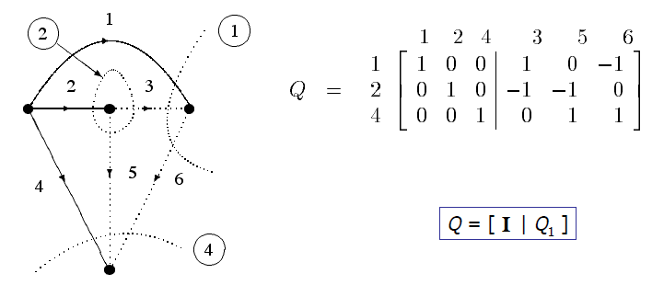

Basic loop: It is a loop containing only one co-tree branch.
Example:
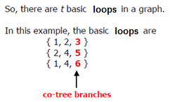

Basic loop matrix (B-matrix):
- The B-matrix describes the way the basic loop is chosen.
- Each column corresponds to a branch (b columns).
- Each row corresponds to a basic loop (b–t rows).
Construction
- For each row: Put a “+1” in the entry corresponding to the loop co-tree branch.
- Put a “0” in the entry corresponding to other co-tree branches.
- Put a “+1” or “–1” in the entry corresponding to each loop tree branch; “+” if it is consistent with the co-tree branch direction and “–” otherwise.

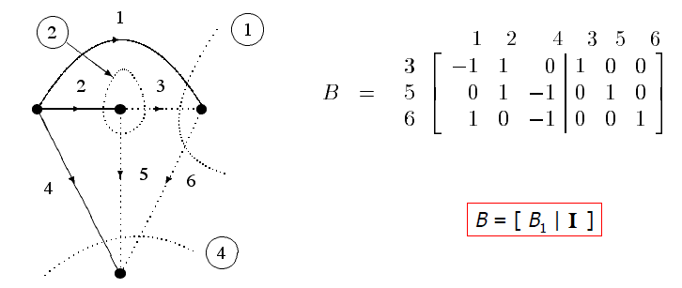

Relationship between Q and B
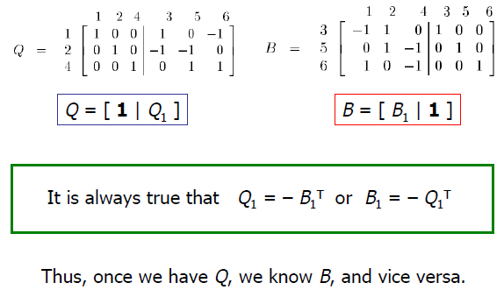

Tie-Set:- It is a set of branches forming a loop through which link current flows.

Example:

Tie-Sets :{ 1, 2, 3}, {2, 4, 5}, {1, 4, 6}

Duality and Dual net works
Duals: Two circuits are said to be duals of one another if they are described by the same characterizing equations with the dual pairs interchanged.
(Or) Two networks are said to be duals, if mesh equations characterize one of them has the same mathematical form as the nodal equations that characterize the other.
Principle of duality: Identical behavior patterns observed between voltage and currents, between two independent circuits illustrate the principle of duality.
Example:
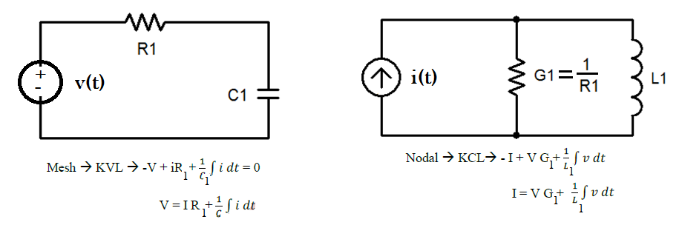

Dual Pairs
Resistance (R) | Conductance (G)
Inductance (L) | Capacitance (C)
Voltage (v) | Current (i)
Voltage Source  v(t)  Vsinωt | Current Source  i(t)  Icosωt
Node | Mesh/Loop
Series Path | Parallel Path
Open Circuit | Short Circuit
KVL | KCL
Thévenin | Norton
Switch in series(getting closed) | Switch in parallel (getting opened)
Procedure to Construct Dual Circuits
- Place a node at the center of each mesh of the circuit.
- Place a reference node (ground) outside of the circuit.
- Draw lines between nodes such that each line crosses an element.
- Replace the element by its dual pair.
- Determine the polarity of the voltage source and direction of the current source.
A voltage source that produces a positive mesh current has as its dual a current source that forces current to flow from the reference ground to the node associated with that mesh.
Example:
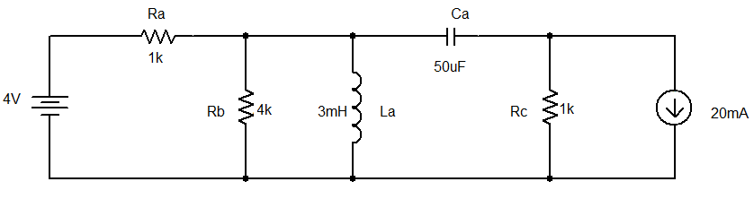
Follow the first three steps
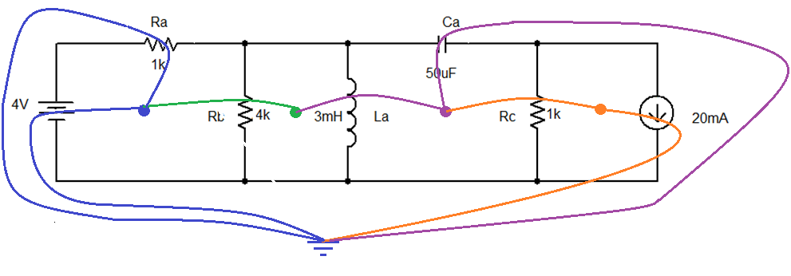
Follow the 4th step replace the elements by its dual pairs
Component in Original circuit | Its Dual
Voltage source (4 V) | Current source (4 A)
Resistor Ra (1 kW) | Conductor R1 (1/1kW = 1 mW)
Resistor Rb (4 kW) | Conductor R2 (1/4kW = 0.25 mW)
Resistor Rc (4 kW) | Conductor R3 (1/1kW = 1 mW)
Inductor La (3 mH) | Capacitor C1 (3 mF)
Capacitor Ca (50 mF) | Inductor L1 (50 mH)
Current Source (20 mA) | Voltage source (20 mV)

Follow the 5th step
- In the original circuit:
  - The voltage source forces current to flow towards Ra.
    - Its dual should force current to flow from the reference ground to the node that is shared by the current source and R1, the dual of Ra.
  - The current source causes current to flow from the node where Rc is connected towards the other meshes.
    - Its dual should cause current to flow from the node between it and R3 to distributed node (reference) of the rest of the circuit.
Draw Dual Circuit
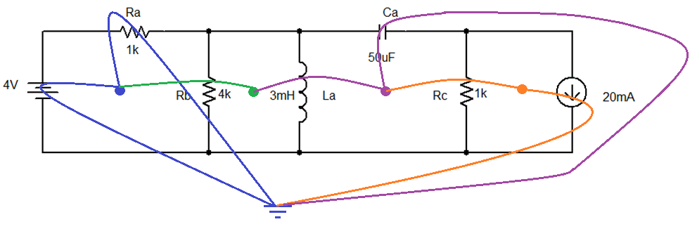
Its dual circuit is
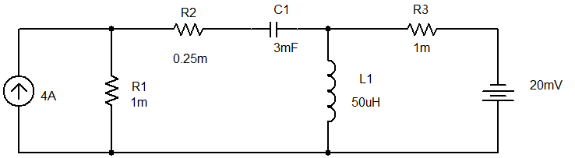

Nodal Analysis:
The aim of nodal analysis is to determine the voltage at each node relative to the reference node (or ground). Once you have done this you can easily work out anything else you need.

The procedure for analyzing a circuit with the node method is based on the following steps.
1. Clearly label all circuit parameters and distinguish the unknown parameters from the known.
2. Identify all nodes of the circuit.
3. Select a node as the reference node also called the ground and assign to it a potential of
0Volts. all other voltages in the circuit are measured with respect to the reference node.
There are a few general guidelines that for the selection of the reference node.
- A useful reference node is one which has the largest number of elements connected to it.
- A useful reference node is one which is connected to the maximum number of voltage sources.
4. Label the voltages at all other nodes.
5. Assign and label polarities.
6. Apply KCL at each node and express the branch currents in terms of the node voltages.
7. Solve the resulting simultaneous equations for the node voltages.
8. Now that the node voltages are known, the branch currents may be obtained from Ohm’s law.

Example: Determine the current I1 in the following circuit

Sol.
1. Label all circuit parameters and distinguish the unknown parameters from the known.
2. Identify all nodes of the circuit and label node voltages.
3. Select a node as the reference node.

- Apply KCL at node 2(V₂) and 3(V₃)
---→1
-→2
Solving the above two equations gives
V2 = 32.34 V
V3 = 40.14 V
and the required current is given by

Nodal analysis with floating voltage sources (or) The Supernode.
If a voltage source is not connected to the reference node it is called a floating voltage source.
In the circuit of Figure 6 the voltage source V_{y} is not connected to the reference node and thus it
is a floating voltage source.
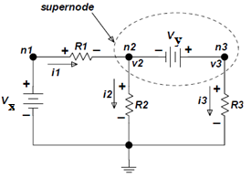
Figure 6. Circuit with a supernode.

The part of the circuit enclosed by the dotted ellipse is called a supernode. Kirchhoff’s current
law may be applied to a supernode in the same way that it is applied to any other regular node.

In our example application of KCL at the supernode gives
i1=i2+i3-------------1
In term of the node voltages Equation (4.22) becomes:
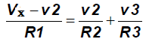--------2
The relationship between node voltages v2 and v3 is the constraint that is needed in order to completely define the problem. The constraint is provided by the voltage source. Vy
Vy=V3-V2-----------3
From 2 and 3 equations determine the node voltages v2 and v3

Example:

Determine the values of the node voltages, v_{a} and v_{b,} for this circuit.

Sol:
Identify the supernode corresponding to the voltage source(Shown below in vowel shape).
Apply KCL to the supernode to get
-----------1

The voltage source voltage is related to the node voltages at by
-----------------2
By solving the 1 and 2 equations

Mesh Analysis
The aim of this method is to find branch currents and Mesh analysis is only applicable to a circuit that is planar.
- A planar circuit is one that can be drawn in a plane with no branches crossing one another.
Example:
The procedure for obtaining the solution with mesh analysis as follow the steps are given below.
1. Clearly label all circuit parameters and distinguish the unknown parameters from the known.
2. Identify all meshes of the circuit.
- A mesh is defined as a loop which does not contain any other loops.
3. Assign mesh currents and label polarities.
4. Apply KVL at each mesh and express the voltages in terms of the mesh currents.
5. Solve the resulting simultaneous equations for the mesh currents.
6. Now that the mesh currents are known, the voltages may be obtained from Ohm’s law.
Example:
Our circuit example has three loops but only two meshes as shown on Figure 9. Note that we have assigned a ground potential to a certain part of the circuit.
Figure 9. Identification of the meshes

Identify the meshes, they are mesh1 and mesh2 and assign the mesh currents, define current direction and voltage polarities.
Figure 10. labeling mesh current direction

Figure 11. Sub-circuit for mesh1 Figure 12. Sub-circuit for mesh2

Apply KVL to mesh1 and mesh2 write the KVL equations as follows

--------1
-----2
Rewrite the equations 1 and 2
--------3
Solve the equation for the mesh currents I1 and I2

